ADO (Microsoft ActiveX Data Object). Net
For this if ASP.Net and web development installed then we can deploy out apps on web
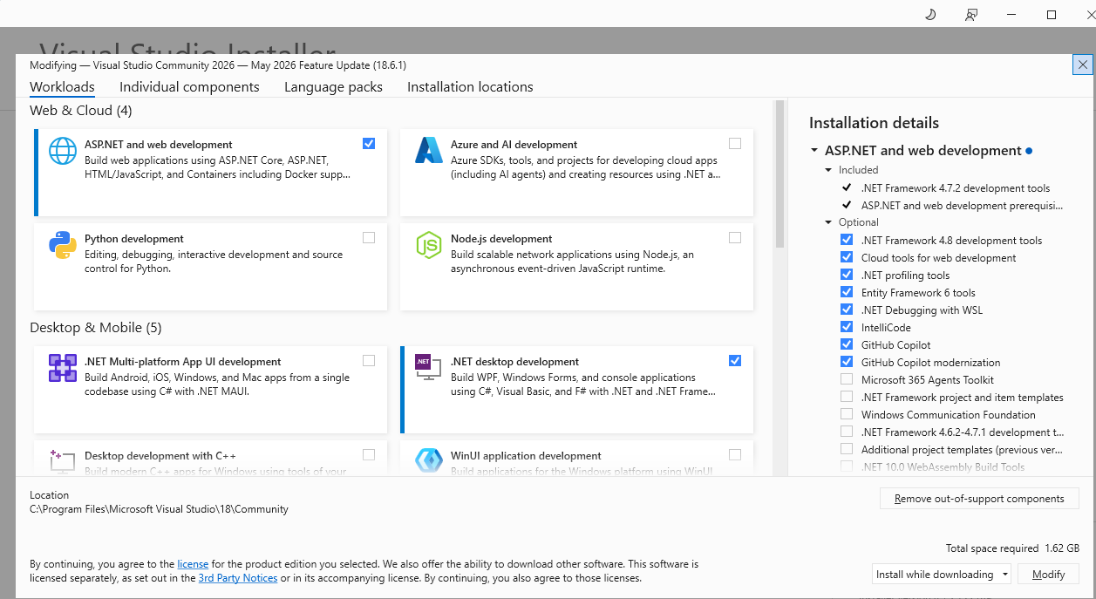
It is recommended to install simple web form
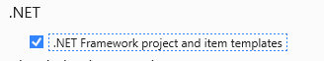
After Installation sample framework will show as below:
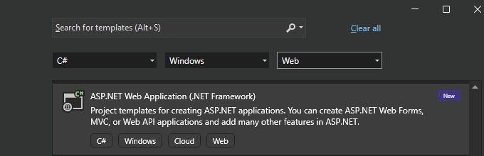
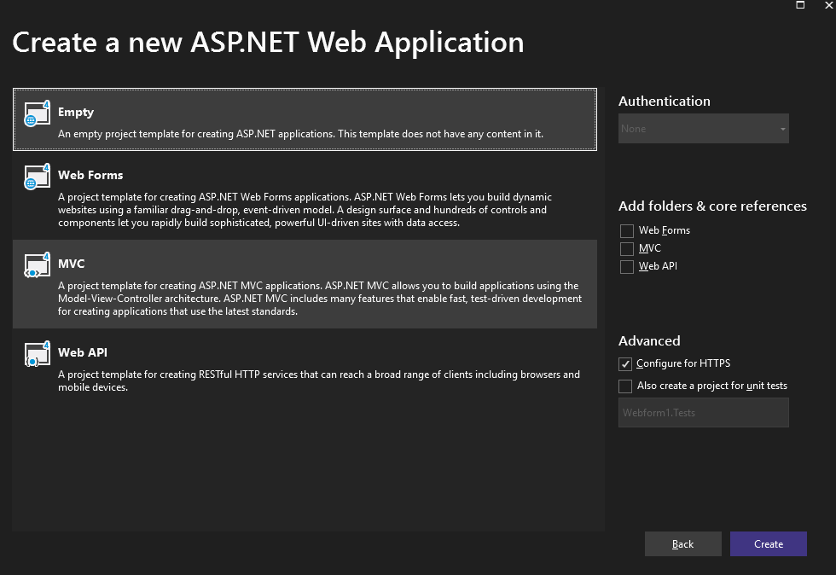

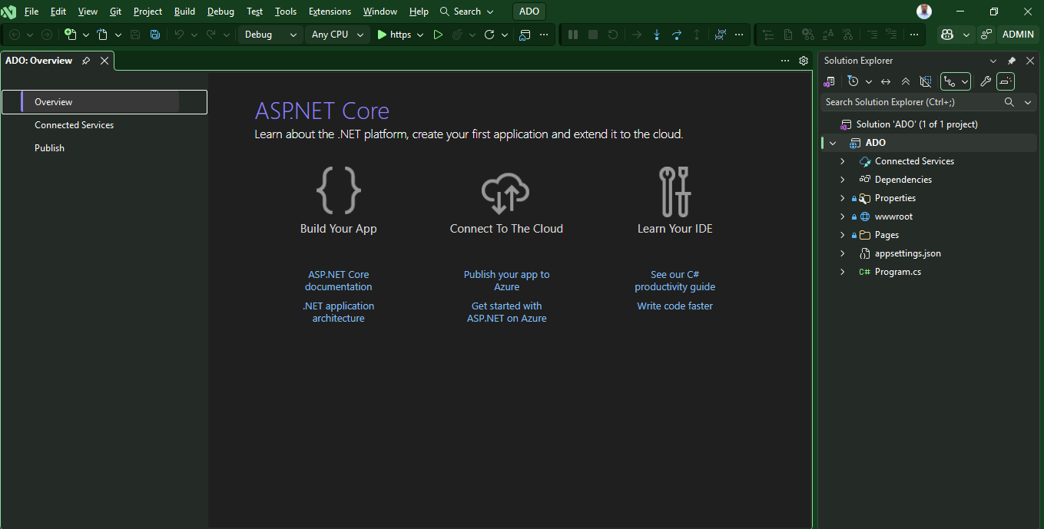
Click on IIS

OUTPUT >>.
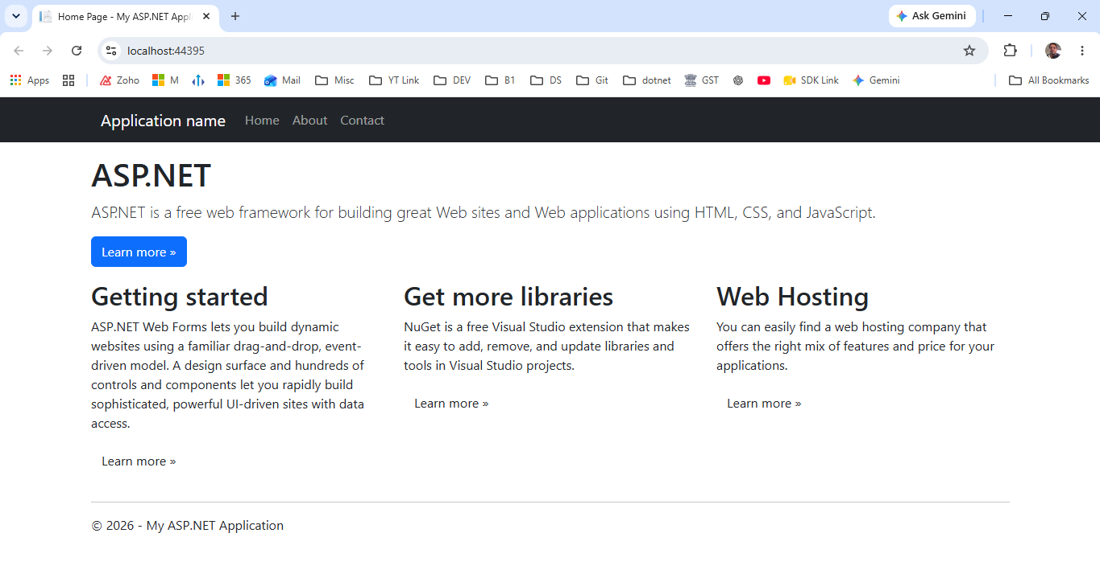
Get Tools and Features if not installed
- What is ADO.NETSQLConnection object in ADO.NET
- Storing and retrieving connection strings from web.config
- SqlCommand in ado.net
- Sql injection tutorial
- Sql injection prevention
- Calling a stored procedure with output parameters
- SqlDataReader object in ADO.NET
- SqlDataReader object's NextResult() method
- SqlDataAdapter in ADO.NET
- DataSet in ASP.NET
- Caching dataset in asp.net
- What is SqlCommandBuilder
- Sqlcommandbuilder update not working
- Disconnected data access in asp.net
- Dataset.rejectchanges and dataset.acceptchanges methods
- Strongly typed datasets
- Load xml data into sql server table using sqlbulkcopy
- Copying data from one table to another table using SqlBulkCopy
- SqlBulkCopy NotifyAfter Example
- Transactions in ADO.NET
- What is ADO.NETSQLConnection object in ADO.NET
- Storing and retrieving connection strings from web.config
- SqlCommand in ado.net
- Sql injection tutorial
- Sql injection prevention
- Calling a stored procedure with output parameters
- SqlDataReader object in ADO.NET
- SqlDataReader object's NextResult() method
- SqlDataAdapter in ADO.NET
- DataSet in ASP.NET
- Caching dataset in asp.net
- What is SqlCommandBuilder
- Sqlcommandbuilder update not working
- Disconnected data access in asp.net
- Dataset.rejectchanges and dataset.acceptchanges methods
- Strongly typed datasets
- Load xml data into sql server table using sqlbulkcopy
- Copying data from one table to another table using SqlBulkCopy
- SqlBulkCopy NotifyAfter Example
- Transactions in ADO.NET

- What is ADO.NETSQLConnection object in ADO.NET
What is ADO.NET?
ADO.NET is not a different technology. In simple terms, you can think of ADO.NET, as a set of classes (Framework), that can be used to interact with data sources like Databases and XML files. This data can, then be consumed in any .NET application. ADO stands for Microsoft ActiveX Data Objects.
The following are, a few of the different types of .NET applications that use ADO.NET to connect to a database, execute commands, and retrieve data.
ASP.NET Web Applications
Windows Applications
Console Applications
What are .NET Data Providers?
Databases only understand SQL. If a .NET application (Web, Windows, Console etc..) has to retrieve data, then the application needs to
1. Connect to the Database
2. Prepare an SQL Command
3. Execute the Command
4. Retrieve the results and display in the application
Sample ADO.NET code to connect to SQL Server Database and retrieve data. Notice that we are using SQLConnection, SQLCommand and SQLDataReader classes . All the objects are prefixed with the word SQL. All these classes are present in System.Data.SqlClient namespace. So, we can say that the .NET data provider for SQL Server is System.Data.SqlClient.
SqlConnection con = new SqlConnection("data source=.; database=Sample; integrated security=SSPI");
SqlCommand cmd = new SqlCommand("Select * from tblProduct", con);
con.Open();
SqlDataReader rdr = cmd.ExecuteReader();
GridView1.DataSource = rdr;
GridView1.DataBind();
con.Close();
Sample ADO.NET code to connect to Oracle Database and retrieve data. Notice that we are using OracleConnection, OracleCommand and OracleDataReader classes . All the objects are prefixed with the word Oracle. All these classes are present in System.Data.OracleClient namespace. So, we can say that the .NET data provider for Oracle is System.Data.OracleClient.
OracleConnection con = new OracleConnection("Oracle Database Connection String");
OracleCommand cmd = new OracleCommand("Select * from tblProduct", con);
con.Open();
OracleDataReader rdr = cmd.ExecuteReader();
GridView1.DataSource = rdr;
GridView1.DataBind();
con.Close();
If we want to connect to OLEDB datasources like Excel, Access etc, we can use OleDbConnection, OleDbCommand and OleDbDataReader classes. So, .NET data provider for OLEDB is System.Data.OleDb.
Different .NET Data Providers
Data Provider for SQL Server - System.Data.SqlClient
Data Provider for Oracle - System.Data.OracleClient
Data Provider for OLEDB - System.Data.OleDb
Data Provider for ODBC - System.Data.Odbc
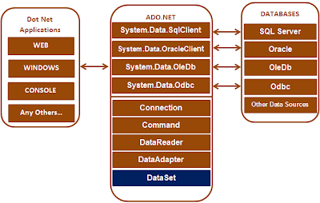
Please note that, depending on the provider, the following ADO.NET objects have a different prefix
1. Connection - SQLConnection, OracleConnection, OleDbConnection, OdbcConnection etc
2. Command - SQLCommand, OracleCommand, OleDbCommand, OdbcCommand etc
3. DataReader - SQLDataReader, OracleDataReader, OleDbDataReader, OdbcDataReader etc
4. DataAdapter - SQLDataAdapter, OracleDataAdapter, OleDbDataAdapter, OdbcDataAdapter etc
The DataSet object is not provider specific. Once we connect to a Database, execute command, and retrieve data into .NET application. The data can then be stored in a DataSet and work independently of the database.

